**Homework5: Sentence-level Sentiment Classification**

I was in between of doing either BERT or LSTM but at the end I have chosen to implement the Bidirectional LSTM.

I tried to draw the BILSTM Architecture by myself to really understand the concept behind this model. This is my drawing:

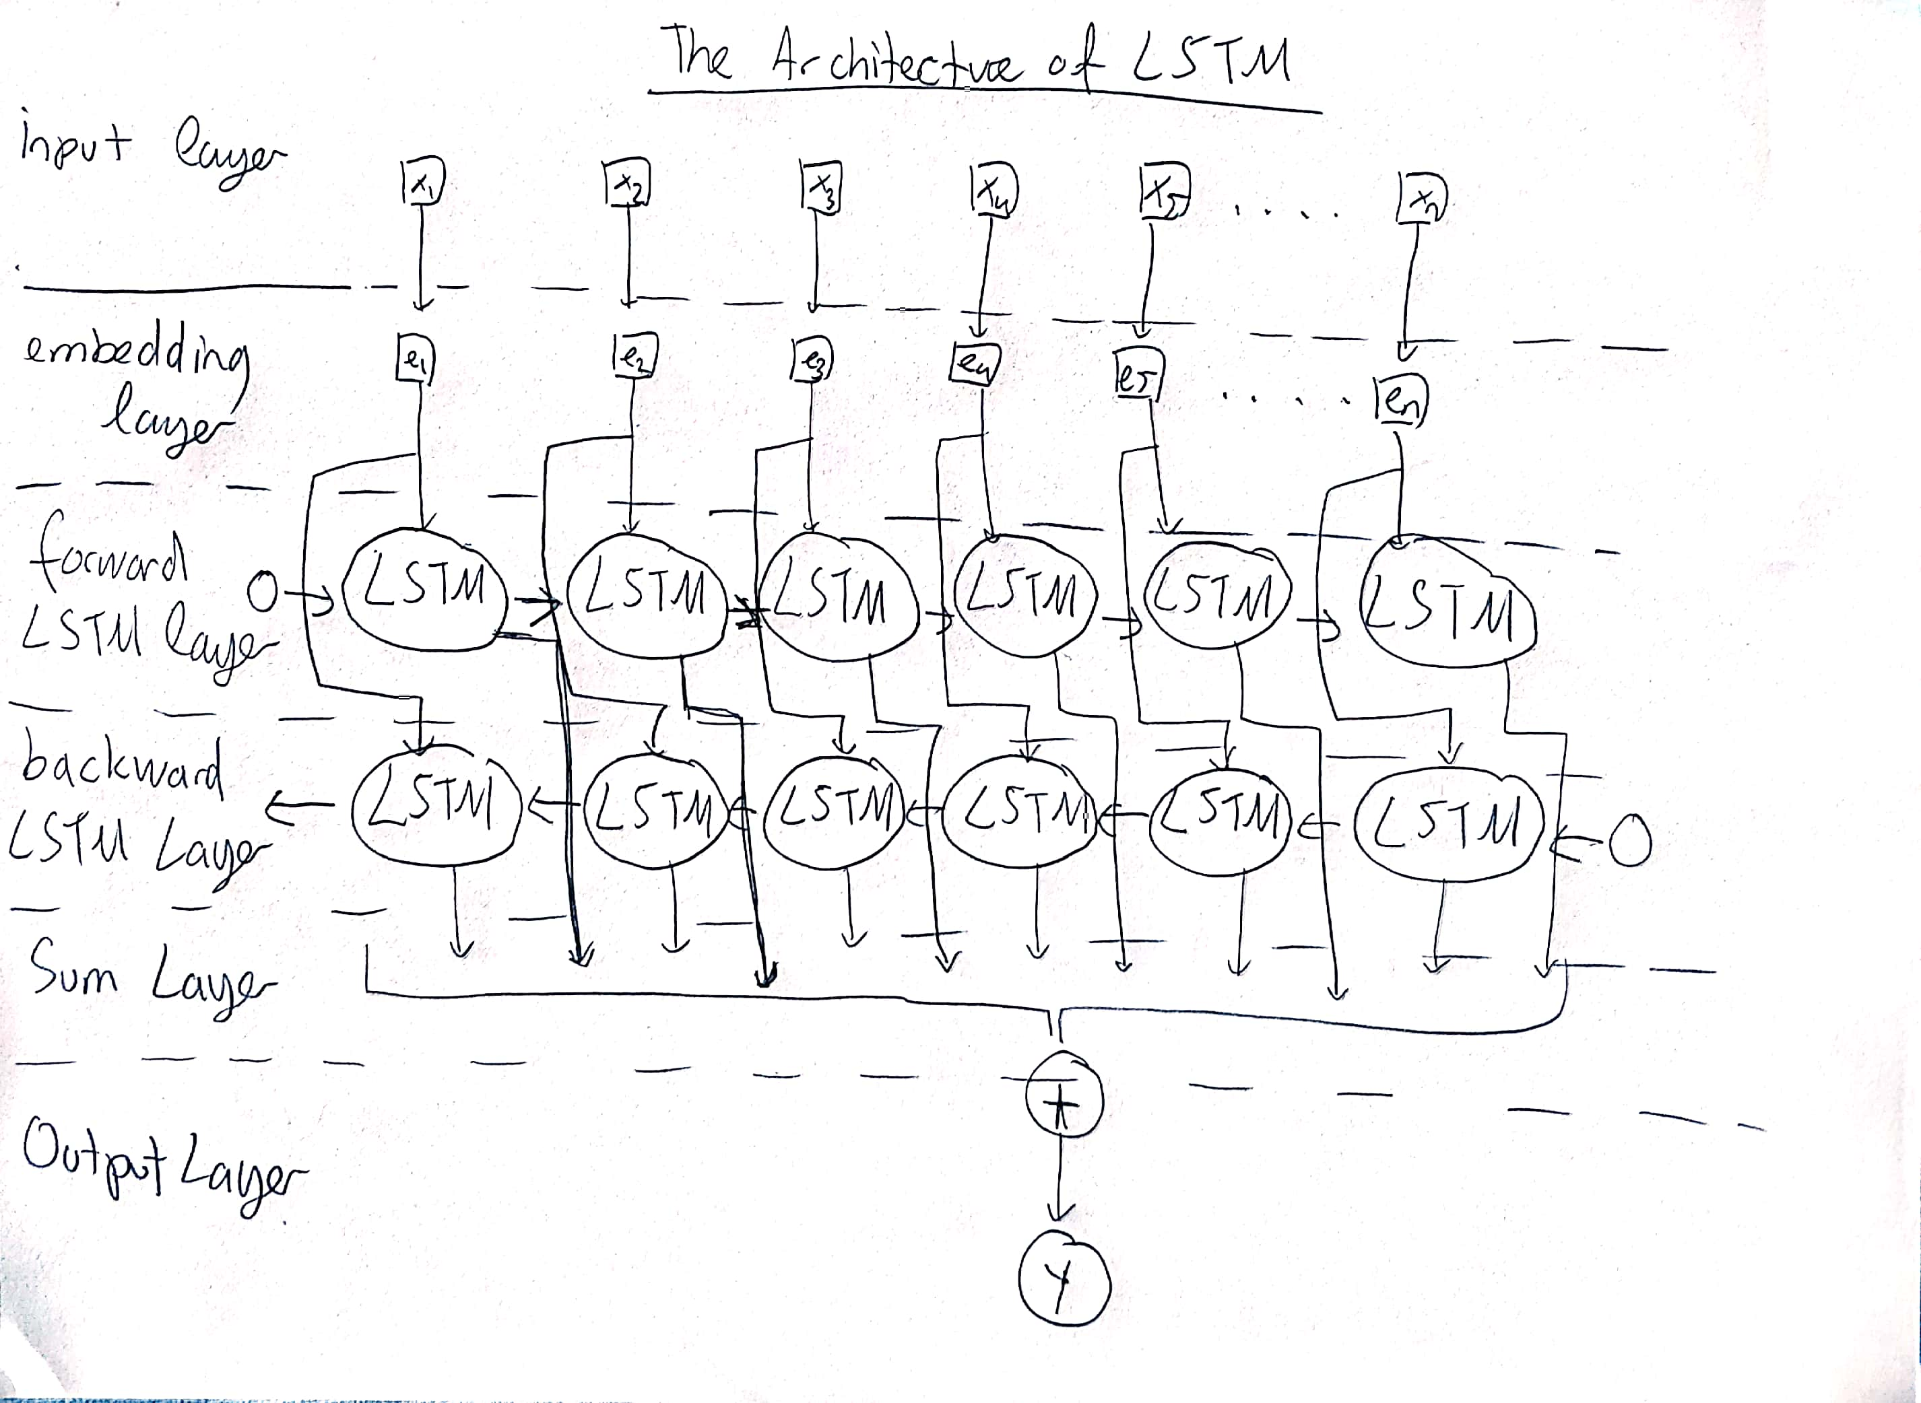

I have used 20 epochs for my implementation because I have a MacBook Air and the CPU power isn’t powerful enough to do long epochs it takes a long time/ Although my epoch was 20 I have achieved promising results.

**My results**



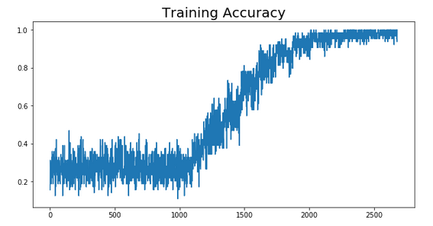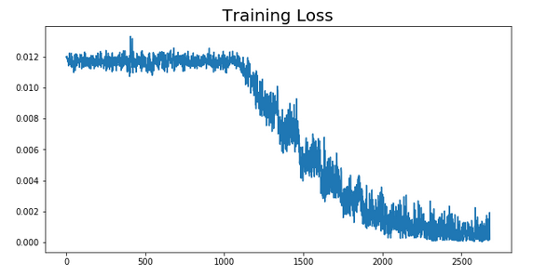



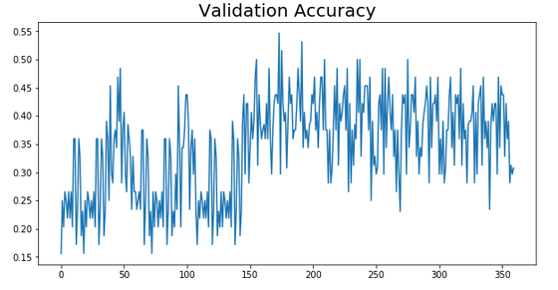

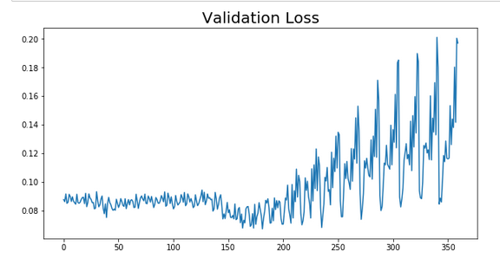

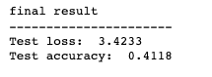

For this type of data with 20 epochs getting these results can be considered okay maybe I could have done slightly better with BERT I will try to implement that on my spare time.